

**CS301 IT Solution Architecture**

**G1 Team 8**

Jasmine Toh Ming Fang - 01373797

Ong Jun Xiang - 01337747

Ng Wen Jie - 01334000

Looi James - 01332928

Chu Wei Hao – 01360083

# **1. Background & Business Needs**

Ascenda enables hotel booking platforms on behalf of partnered hotels, banks, airlines, and loyalty programs, allowing customers to earn & redeem hotel night stays. As an aggregator, Ascenda collects pricing results from many different hotel partners, of which customers will be able to view, earn and redeem hotel night stays on the hotel booking platform.

Ascenda’s hotel booking platform is an ecommerce website, hence, **speed** is deemed to be the most important business needs for a pleasant user experience. For Ascenda to remain competitive, the hotel booking platform would have to produce results on the customers’ browsers almost instantaneously. Furthermore, during peak periods and especially in post-pandemic times, the hotel booking platforms must be extremely **scalable** to meet the larger spikes in demand. Additionally, Ascenda deploys daily, and no downtime is allowed during deployment, meaning our solution must be **maintainable**. Ascenda also strives to ensure that the payment information, personal information, and services are **secure**.

Hence, our solution will have to consider the tradeoff between speed and accuracy of results to meet the abovementioned Ascenda’s business needs.

# **2. Stakeholders**

|  |  |  |
| --- | --- | --- |
| **Stakeholder** | **Stakeholder Description** | **Permissions** |
| **Business Stakeholders** | | |
| Ascenda | Ascenda acts as the middleman, providing the brokerage/bridging service between hotels and end-users | - Read: Global Access  - Write: Global Access |
| Hotels | Ascenda’s clients and partners. Ascenda collects pricing results from different hotel partners and displays their information on the hotel booking platform. | N.A. |
| Customers | Customers interact with the platform to perform various functions, such as retrieving accurate hotel information and displaying the lowest price by hotel and/or by destination. | - Read: Get latest  available hotel information  - Write: Booking & payment information |
| **IT Stakeholders** | | |
| AWS | AWS provides Ascenda with the  infrastructure and services to deploy and manage the applications. As an IT stakeholder, Ascenda is expected to use their services legally and to perform all the necessary security configuration and management tasks | N.A. |
| Ascenda’s Development Team | Ascenda’s Development Team is  responsible for the development of features that fulfill the needs of the hotel booking platform. | - Read: Global Access  - Write: Global Access |
| Ascenda’s Maintenance Team | Ascenda’s Maintenance Team is responsible for the availability, scalability, and security of the solution. | - Read: Global Access  - Write: Global Access |

# **3. Key Use Cases**

|  |  |
| --- | --- |
| **Use Case Title – Search Destination by Location** | |
| **Use Case ID** | 01 |
| **Description** | Customers will be able to input a location to query for hotels located in specified location. This is significant as Ascenda aims to provide a fast and accurate search of available hotels for their customers. |
| **Actors** | System, Customer |
| **Main Flow of events** | 1. Customer inputs location data in the search bar. 2. The frontend will call the Ascenda’s API. 3. Backend takes in relevant parameters and queries the database to retrieve the relevant hotel results. 4. Backend microservice returns JSON result to the frontend. 5. Customer’s frontend displays available hotels |
| **Alternative Flow of events** | Invalid Location. Error Message, UI will display the “No hotel available in the specifed location” message. |
| **Pre-conditions** | Ascenda API endpoint must be available.  System needs to prepare location list.  Port connection from microservice to database established.  Customer input form displayed. |
| **Post-conditions** | System webpage displays correct/relevant hotel search results |

|  |  |
| --- | --- |
| **Use Case Title – Autocompletion of User’s Destination Search Input** | |
| **Use Case ID** | 02 |
| **Description** | System will be able to autocomplete Customer input for the location field. This is an important feature to help improve the customer’s user experience greatly. |
| **Actors** | System, Customer |
| **Main Flow of events** | 1. Customer types in text in the search bar 2. Input text will be autocompleted by the system by providing suggestions on the webpage |
| **Alternative Flow of events** | System unable to recognise text input and is not able to provide autocompletion |
| **Pre-conditions** | System needs to prepare location list.  Port connection to database established.  Customer input form displayed.  Recommender system operational. |
| **Post-conditions** | System webpage displays correct/relevant autocomplete results |

|  |  |
| --- | --- |
| **Use Case Title –View Available Rooms** | |
| **Use Case ID** | 03 |
| **Description** | Customer should be able to view all available rooms based on a hotel, dates of stay, number of rooms, number of guests. This functionality provides customer to sort available rooms based on the various input parameters. |
| **Actors** | System, Customer |
| **Main Flow of events** | 1. Customer inputs parameter data in the frontend UI 2. The frontend will call the Ascenda’s API using the Customer’s search query. 3. Backend takes in parameters and queries the database to retrieve the relevant hotel rooms results. 4. Backend microservice return JSON result to frontend. 5. Customer’s frontend UI displays available hotel rooms. |
| **Alternative Flow of events** | No available room, UI will display message, “No rooms available”. |
| **Pre-conditions** | Ascenda’s API endpoint is available  Ports are configured to accept data packets |
| **Post-conditions** | Customer’s client page displays all available rooms |

|  |  |
| --- | --- |
| **Use Case Title – View Hotels by Price** | |
| **Use Case ID** | 04 |
| **Description** | System renders a listing view of all available hotels and cheapest room of each hotel from Ascenda’s API. This use case is important because customers would be interested in the cheapest and most accurate hotel room prices. |
| **Actors** | Database |
| **Main Flow of events** | 1. Customers send search query. 2. Backend retrieves all available hotel results sorted by price. 3. Ascenda’s API returns result as a JSON response. 4. The response would be rendered back on the client’s side. |
| **Alternative Flow of events** | No results, display error message on UI, “Error, please try again” |
| **Pre-conditions** | Valid search parameters |
| **Post-conditions** | Returns result in ascending price |

|  |  |
| --- | --- |
| **Use Case Title – Login To System** | |
| **Use Case ID** | 05 |
| **Description** | Customer logs in to their account to view their relevant details. This provides users a personalised experience as their history with the system can be utilised for future interactions (suggestions/discounts) |
| **Actors** | System, Customer |
| **Main Flow of events** | 1. Customer lands on the website’s homepage which prompts log in to access system functionality. 2. Customer inputs username and password and logs in. 3. Customer is redirected to booking page / page where they left off. |
| **Alternative Flow of events** | User input wrong login credential, UI displays error message, “Username/Password incorrect, please try again” |
| **Pre-conditions** | System needs to prepare login page.  Port connection to user database established.  Customer login input form displayed.  Login data validation must be up. |
| **Post-conditions** | Customer will be redirected to the user summary page to view their booking details or make a new booking. |

|  |  |
| --- | --- |
| **Use Case Title – Book Hotel** | |
| **Use Case ID** | 06 |
| **Description** | Customer will be able to make a hotel booking after providing their booking details. Thereby generating revenue for the hotels utilising the system as an additional channel of customer acquisition. |
| **Actors** | Customer, System, Hotel API |
| **Main Flow of events** | 1. Customer will check their booking information and submit, following which the customer will be redirected to make payment. 2. Upon successful purchase verified by the system, customers will be redirected to the booking summary page |
| **Alternative Flow of events** | Customer transaction failed. Will be sent back to the booking page with error message displayed on the UI. |
| **Pre-conditions** | System needs to prepare booking and summary page.  Port connection to user database established.  Booking page displayed.  Payment system needs to be up.  Hotel Booking API needs to be up. |
| **Post-conditions** | Customer will be redirected to the booking summary page. |

|  |  |
| --- | --- |
| **Use Case Title – Checks Booking Information (Post-Purchase)** | |
| **Use Case ID** | 07 |
| **Description** | Customers will be able to view their past bookings upon login / successful purchase. Thereby allowing them to check on various details associated with previous bookings such as date, amount spent, etc. |
| **Actors** | Customer, System |
| **Main Flow of events** | 1. Upon logging in / making a successful purchase, customer will be able to view a summary of their recent booking details. 2. Users will also be able view relevant details of each of their previous hotel bookings upon clicking on the respective booking |
| **Alternative Flow of events** | Transaction / login error. Error message will be displayed on the UI. |
| **Pre-conditions** | System needs to prepare booking summary page.  Port connection to user database established.  Login data validation must be up. |
| **Post-conditions** | Customer will have the option to make a new purchase / print page / logout. |

# **4. Quality Attributes**

|  |  |
| --- | --- |
| **Quality Attribute** | |
| **Performance Efficiency** | |
| Autocompleting of destination | < 100ms per request (average from 1000 request) |
| Caching | To ensure quick auto completion, hotel and destination id-name mapping is cached at the frontend (Local Storage) so the retrieval and of relevant results are brought to the customers with little delay. |
| Load balancer | To ensure our system can main high capacity, load balance can be used as a reverse proxy and to handle more user requests especially when there is a spike in user load. |
| **Reliability** | |
| Availability | 99.9% uptime |
| Datacenter in separate availability zones | Ensure that there are separate regions to failover to for high availability. |
| Active/passive standby | Ensure the web app instances on a separate availability zone for redundancy |
| AWS Load Balancing | Application Load Balancing (ALB) will be used as a reverse proxy. |
| AWS Auto-scaling Group | Auto Scaling will create a new instance when CPU utilization reaches 80% and destroys an excess instance when CPU utilization is less than 20% |
| **Maintainability** | |
| AWS CodeDeploy | Helps to rapidly release new features and help to achieve zero downtime during deployment and handles the complexity of updating the application. |
| **Security** | |
| General Web Security | Metric for security: Get a minimum of B grade for Mozilla Observatory Results |
| OWASP Secure Coding Practices | Ensure Secure Coding Practices are followed and updated annually as per OWASP standards |
| WAF Filter Rule Firewall | Implement firewall to prevent XSS attacks and SQL injections |
| Separate Web and Database Servers in DMZ | Implement different security layers |
| SSL Certification | Enable https connection to protect server-client connection |
| Revalidate data on server side | Minimize the risks of HTTP parameter tampering |

## **5. Proposed Budgets**

|  |  |  |
| --- | --- | --- |
| **Activity/ Hardware/Software/ Service** | **Description** | **Cost ($/Month)** |
| AWS Application Load Balancer | Load Balancer will act as the reverse proxy and at the same time allow for high availability **(1 ALB, 15LCUs)** | Within [Free Tier](https://aws.amazon.com/free/?all-free-tier.sort-by=item.additionalFields.SortRank&all-free-tier.sort-order=asc) |
| RDS MySQL | MySQL RDS used as buffer cache.  **(20GB, Multi-AZ)** | Within [Free Tier](https://aws.amazon.com/free/?all-free-tier.sort-by=item.additionalFields.SortRank&all-free-tier.sort-order=asc) |
| AWS S3 | Storage of Application files and other resources  **(5GB/Month)** | Within [Free Tier](https://aws.amazon.com/free/?all-free-tier.sort-by=item.additionalFields.SortRank&all-free-tier.sort-order=asc) |
| AWS API Gateway | Allow communication between VPC and internet  **(40KB Average Request Size, 1 million request/month)** | Within [Free Tier](https://aws.amazon.com/free/?all-free-tier.sort-by=item.additionalFields.SortRank&all-free-tier.sort-order=asc) |
| AWS Virtual Private Cloud (VPC) | Private cloud to host internal servers | Within [Free Tier](https://aws.amazon.com/free/?all-free-tier.sort-by=item.additionalFields.SortRank&all-free-tier.sort-order=asc) |
| AWS CloudWatch | An application-based monitoring of EC2 instances **(10 Metrics)** | Within [Free Tier](https://aws.amazon.com/free/?all-free-tier.sort-by=item.additionalFields.SortRank&all-free-tier.sort-order=asc) |
| AWS CloudFront | It is a fast content delivery network (CDN) service that allows us to quickly deliver hotel destination data and images to the frontend with low latency and high transfer speeds.  **(50GB Data Transfer Out)** | Within Free Tier |
| AWS Lambda | A serverless compute function that runs the code on demand or in response to events. **(1 Million Requests/Month)** | Within Free Tier |
| AWS Elastic Beanstalk (EBS) | EBS will be used to manage hosting & deployment of the backend APIs developed with Flask **(2 x t2.micro instances)** | $6.26 (Free tier covers 1 t2.micro) |
| AWS CodeDeploy | Enable zero downtime deployment **(2 instances + 10 deployments/month)** | $0.40 |
| Domain name | For Ascenda website to have a Domain Name for users to access  **(Domain.com > “hotelbooker.tech”)** | $6.99 |
| AWS WAF  (Web Application Firewall) | It will be used to help to protect our system against common web exploits that may affect availability, compromise security, or consume excessive resources. It also gives us the control over how traffic reaches our applications by allowing us to create security rules that block common attack patterns.  **(1 Web ACL, 1 Million Request/Month)** | $5.60 |
| Total Monthly Cost | | **$19.25** |

# **6. Design View**

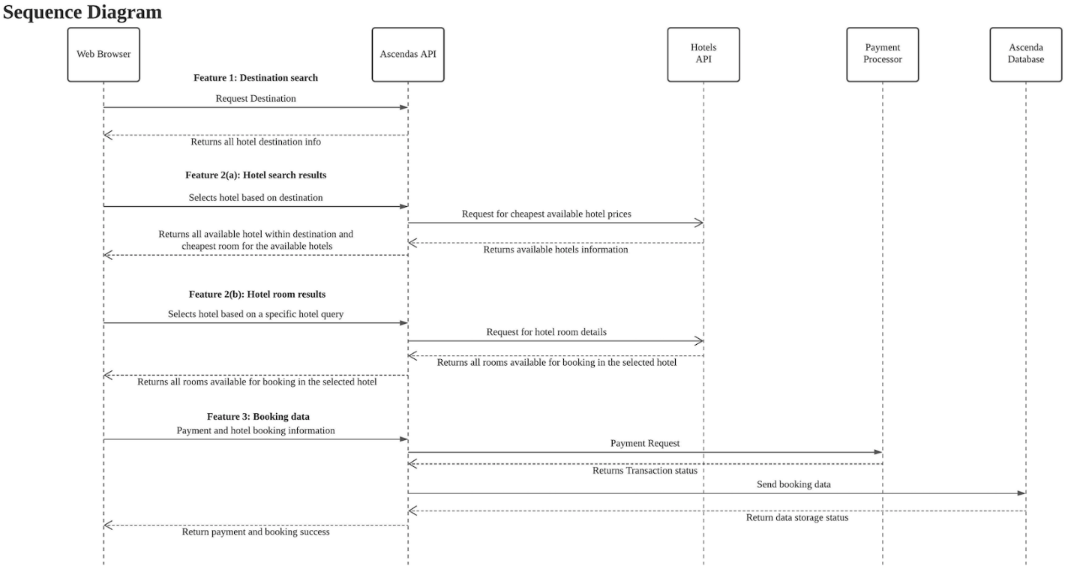

# **7. Development View**

## 7.1 Architecture Diagram

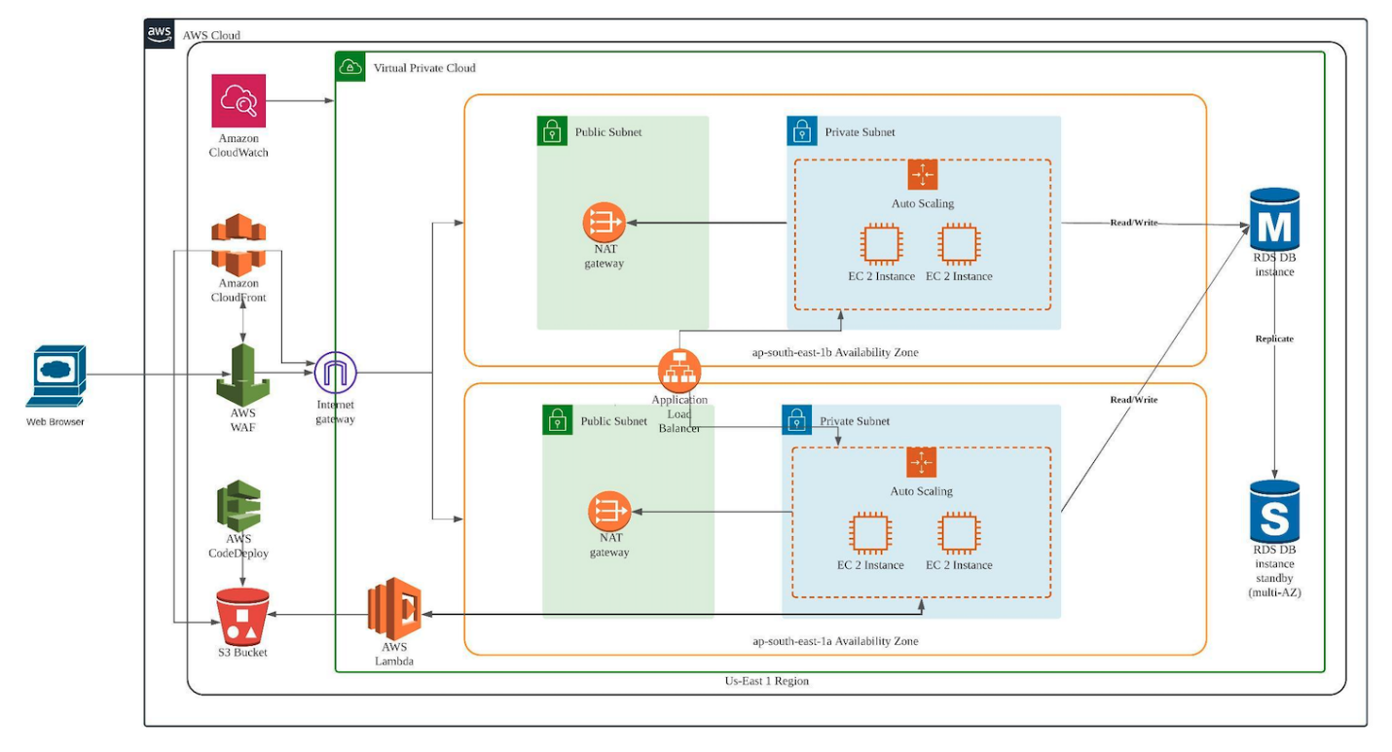

## 7.2 Deployment Diagram

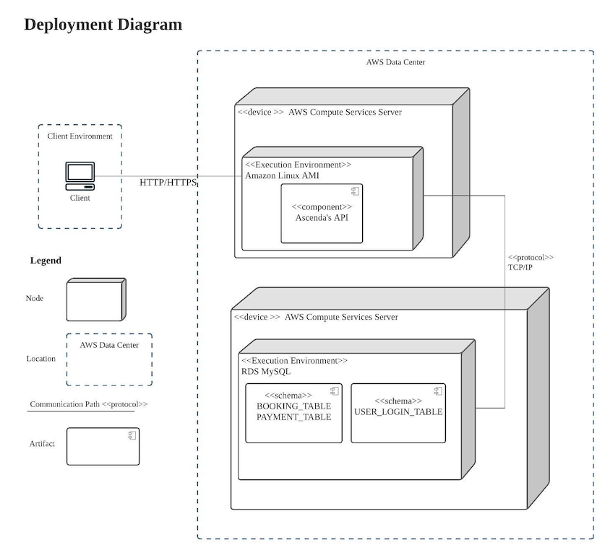

**Appendix A: UI for Searching Hotels via Destination**

**Appendix B: UI for Searching Hotel Rooms via Hotel**

**Appendix C: Mockup UI for Displaying Hotel Results**

